Experiment 5
Description: Create a simple cloud software application for Library book reservation system for SIMATS library using any Cloud Service Provider to demonstrate SaaS.
Aim
To create a cloud-based library reservation platform and host it as a SaaS application.
Procedure
- Create modules: Book Search, Reservation Panel, Issue Request.
- Store book inventory in cloud database.
- Deploy the system on a cloud platform.
- Test book search and reservation features.
Output:
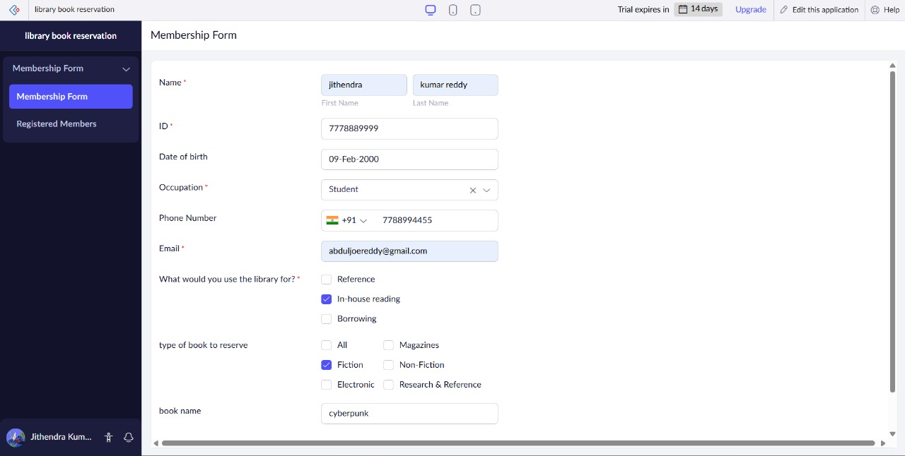
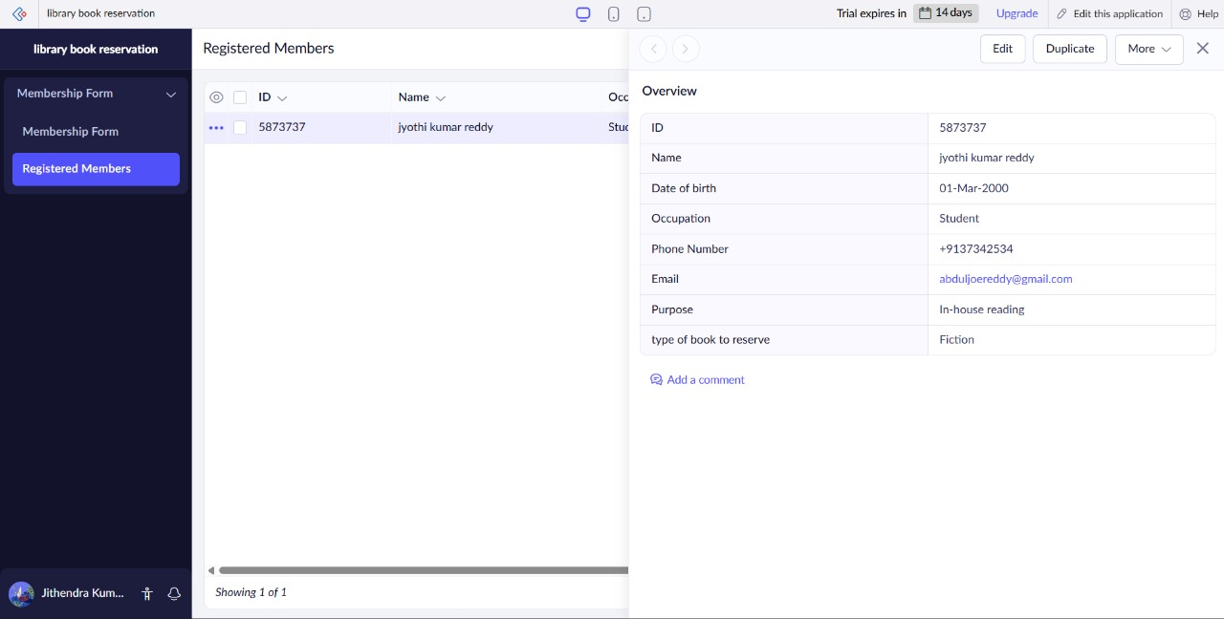
Result
Library reservation system was successfully created and deployed as SaaS.

